Lichen Planus

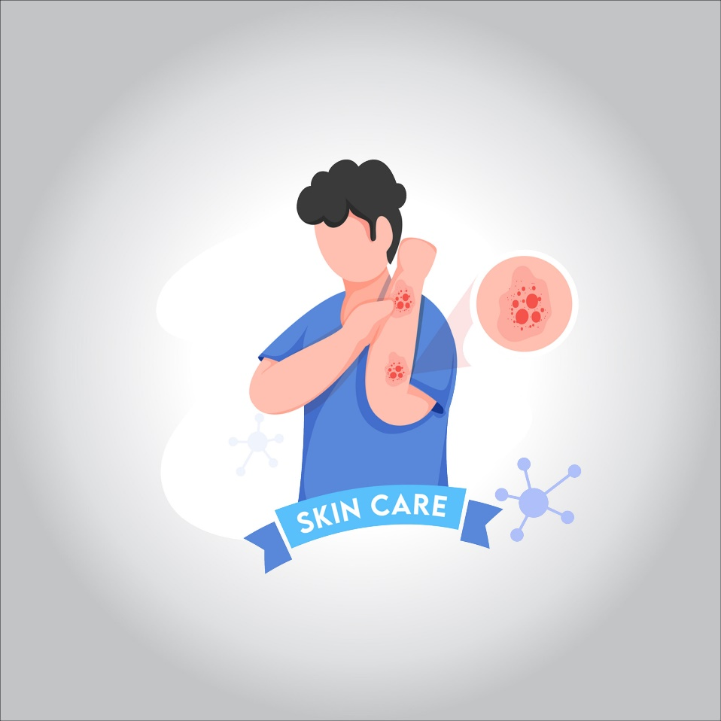

**Lichen planus is a condition that can cause swelling and irritation in the skin, hair, nails and mucous membranes. On the skin, lichen planus usually appears as purplish, itchy, flat bumps that develop over several weeks. In the mouth, vagina and other areas covered by a mucous membrane, lichen planus forms lacy white patches, sometimes with painful sores.**

**Most people can manage typical, mild cases of lichen planus at home, without medical care. If the condition causes pain or significant itching, you may need prescription drugs. Lichen planus isn’t contagious.**

**What are the symptoms?**

**The signs and symptoms of lichen planus vary depending on the areas affected. Typical signs and symptoms are:**

* **Purplish, flat bumps, most often on the inner forearm, wrist or ankle, and sometimes the genitals**
* **Itching**
* **Blisters that break to form scabs or crusts**
* **Lacy white patches in the mouth or on the lips or tongue**
* **Painful sores in the mouth or vagina**
* **Hair loss**
* **Change in scalp color**
* **Nail damage or loss**

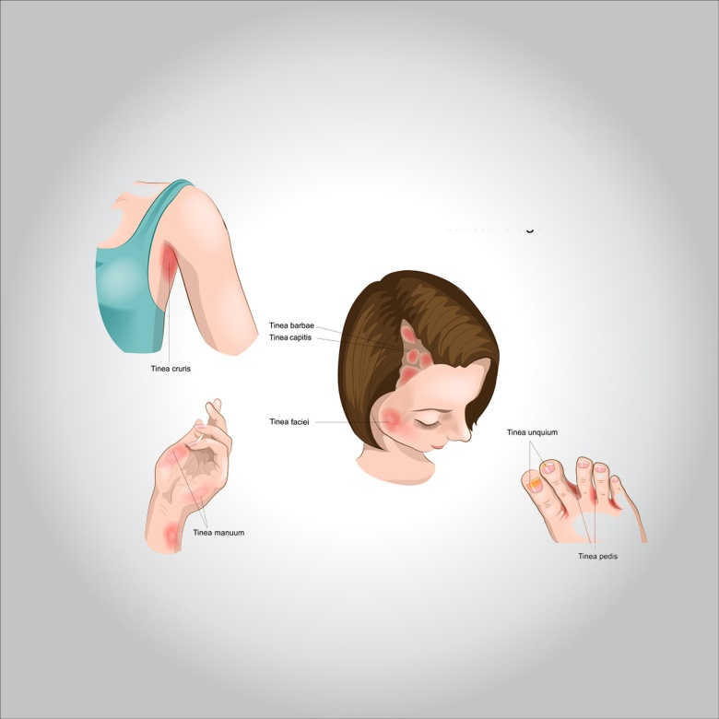

**When to see a doctor!**

**See your doctor if tiny bumps or a rash-like condition appears on your skin for no apparent reason, such as a known allergic reaction or contact with poison ivy. Also see your doctor if you experience any signs or symptoms associated with lichen planus of the mouth, genitals, scalp or nails.**

**What are the causes?**

**Lichen planus occurs when your immune system attacks cells of the skin or mucous membranes. It’s not clear why this abnormal immune response happens. The condition isn’t contagious.**

**Lichen planus can be triggered by:**

* **Hepatitis C infection**
* **Flu vaccine**
* **Certain pigments, chemicals and metals**
* **Pain relievers, such as ibuprofen (Advil, Motrin IB, others) and naproxen (Aleve, others)**
* **Certain medications for heart disease, high blood pressure or arthritis**

**Complications**

**Lichen planus can be difficult to manage on the vulva and in the vagina, causing severe pain and sometimes leaving scars. Sexual dysfunction can become a long-term complication. Oral sores may affect your ability to eat. The affected skin might stay slightly darker even after the rash clears up, especially in dark-skinned people.**

**Oral lichen planus increases the risk of oral cancer. Left untreated, lichen planus of the ear canal may lead to hearing loss.**

**What is the diagnosis?**

**Your doctor makes a diagnosis of lichen planus based on your symptoms, your medical history, a physical examination and, if necessary, the results of lab tests. These tests may include:**

* **Biopsy. Your doctor removes a small piece of affected tissue for examination under a microscope. The tissue is analyzed to determine whether it has the cell patterns characteristic of lichen planus.**
* **Hepatitis C test. You may have your blood drawn to test for hepatitis C, which is a possible trigger for lichen planus.**
* **Allergy tests. Your doctor may refer you to an allergy specialist (allergist) or dermatologist to find out if you’re allergic to something that can trigger lichen planus.**

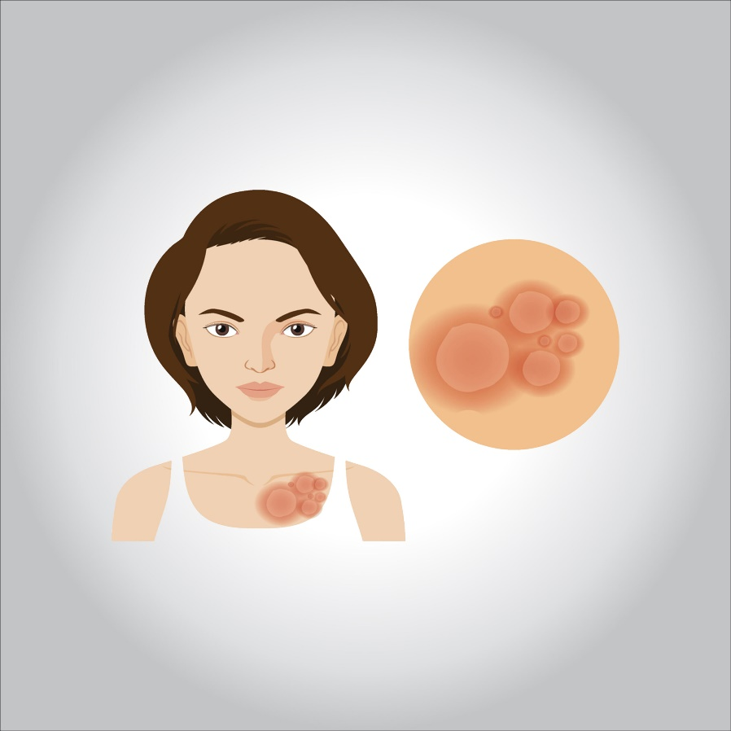

**What is the treatment?**

**Lichen planus on the skin often clears up on its own in months to years. If the disease affects your mucous membranes, it tends to be more resistant to treatment and prone to recur. Whatever treatment you use.**

**Medications and other treatments might help relieve itching, ease pain and promote healing. Therapy can be challenging. Talk with your doctor to weigh the potential benefits against possible side effects of treatment.**

**Corticosteroids**

**The first choice for treatment of lichen planus is usually a prescription corticosteroid cream or ointment. If that doesn’t help and your condition is severe or widespread, your doctor might suggest a corticosteroid pill or injection.**

**Common side effects of topical corticosteroids include skin irritation or thinning where the cream is applied and oral thrush. Corticosteroids are considered safe when taken as directed and for short-term use.**

**Oral anti-infections drugs**

**Other oral medicines used in selected situations for this condition are the antimalarial hydroxychloroquine (Plaquenil) and the antibiotic metronidazole (Flagyl, others).**

**Immune response medicines**

**Severe signs and symptoms may require prescription medications that suppress or modify your body’s immune response.**

**Antihistamines**

**An antihistamine medication taken by mouth might relieve the itching of lichen planus.**

**Light therapy**

**Light therapy (phototherapy) may help clear up lichen planus affecting the skin. The most common phototherapy for lichen planus uses ultraviolet B (UVB) light, which penetrates only the upper layer of skin (epidermis). Light therapy usually requires two to three treatments a week for several weeks.**

**This therapy isn’t recommended for dark-skinned people, who have an increased risk of their skin staying slightly darker even after the rash clears up.**

**Retinoids**

**If your condition doesn’t respond to corticosteroids or light therapy, your doctor might prescribe a retinoid medication taken by mouth, such as acitretin (Soriatane).**

**Retinoids can cause birth defects, so these drugs aren’t recommended for women who are pregnant or may become pregnant. If you’re pregnant or nursing, your doctor may opt to delay topical retinoid therapy or choose a different treatment.**

**Dealing with triggers**

**If your doctor suspects that your lichen planus is related to hepatitis C infection, allergies or a drug you take, you might need other treatment. For example, you may need to switch medications or avoid offending allergens. Your doctor may refer you to an allergist or, in the case of a hepatitis C infection, a specialist in liver disease (hepatologist) for further treatment.**

**Lifestyle and home remedies**

**Self-care measures can help reduce the itching and discomfort caused by lichen planus. These include:**

* **Soaking in a bathtub with colloidal oatmeal (Aveeno, others), followed by moisturizing lotion**
* **Applying cool compresses**
* **Using an over-the-counter hydrocortisone cream or ointment, containing at least 1 percent hydrocortisone (if you’re not using a prescription topical corticosteroid)**
* **Avoiding scratching or injuring your skin**

**For oral lichen planus, good oral hygiene and regular dentist visits are important. You can help reduce the pain of mouth sores by avoiding:**

* **Smoking**
* **Drinking alcohol**
* **Consuming spicy or acidic food and drink**